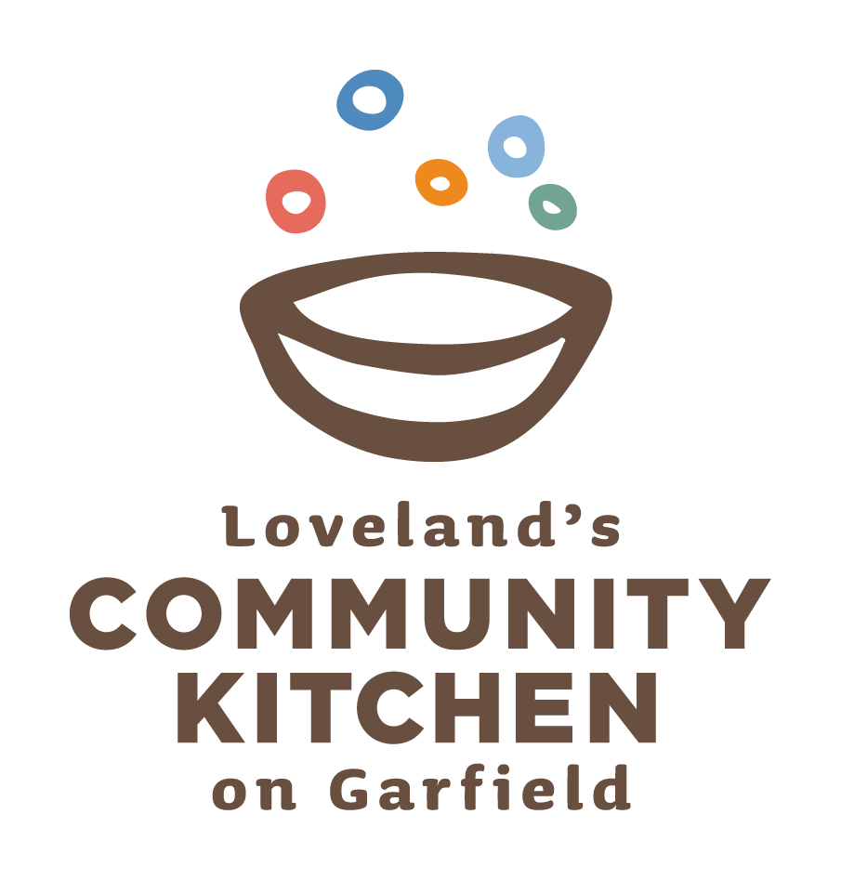
Community Kitchen 2nd Annual Cajun Boil Fundraiser
SPONSORSHIP FORM

Sponsorship/Underwriter: Dollar Amount:_

Organization:

Contact Person:

Address:

Phone: ______________________________ E-mail:

Payment Method*: Cash/Check______________ Credit Card

Please make checks out to Community Kitchen.

Signature:________________________________________________________________________________

Sponsorship Levels:

Bourbon Street - $5,000
14 tickets
Logo on Ticket
Verbal Recognition
Full Page Ad in the Program
3 Sponsorship Banners (sponsor provides)
Table Top Sponsor

The Big Easy - $2,500
10 tickets
Half Page Ad in the Program
2 Sponsorship Banners (sponsor provides)
Table Top Sponsor

Ragin’ Cajun - $1,000
6 tickets
Quarter Page Ad in the Program
1 Sponsorship Banners (sponsor provides)
Table Top Sponsor

Creole - $500
4 tickets
Eighth Page Ad in the Program
Table Top Sponsor

Underwriters:

$1,000 Level
Band
Cuisine
Tents
$500 Level
Beer & Wine
Stage
Program
$250 Level
Decorations
Tickets
Signage

Return completed forms and mail payment to: Teresa Mueller, c/o Mueller & Associates, CPA LLC,
762 West Eisenhower, Loveland CO 80537

